Title: Crop Recommendation System Using Machine Learning
Done by : Pritesh Ram Keshri Project Number : 15, Submission Date: 17th July 2025
Overview:

This project aims to recommend the most suitable crop to cultivate based on soil and weather conditions using a machine learning classification model. The model is trained on a labeled dataset containing key agricultural factors such as nutrient levels and environmental parameters, helping farmers make data-driven decisions.
Libraries used:

- pandas, numpy – Data manipulation and array handling
- scikit-learn – Model building, evaluation, preprocessing
- joblib – Model serialization
- streamlit – Web interface for real-time predictions

Dataset Details:

- Source:https://www.kaggle.com/datasets/atharvaingle/crop-recommendation-dataset(Crop_recommendation.csv)
- Features:
- N (Nitrogen)
- P (Phosphorus)
- K (Potassium)
- temperature (in °C)
- humidity (in %)
- ph (pH value of soil)
- rainfall (in mm)
- Target: Label (crop name like rice, maize, etc.)

APIs Integrated:

No external APIs were used.

Source code 1: File Name : Model Training (train.py)
import pandas as pd
from sklearn.model_selection import train_test_split
from sklearn.ensemble import RandomForestClassifier
from sklearn.preprocessing import LabelEncoder
from sklearn.metrics import accuracy_score, classification_report
import joblib

# Load dataset
df = pd.read_csv("data/Crop_recommendation.csv")

# Encode target labels
le = LabelEncoder()
df['label'] = le.fit_transform(df['label'])

# Feature and target split
X = df.drop('label', axis=1)
y = df['label']

# Train-test split
X_train, X_test, y_train, y_test = train_test_split(X, y, test_size=0.2, random_state=42)

# Model training
model = RandomForestClassifier(random_state=42)
model.fit(X_train, y_train)

# Evaluation
y_pred = model.predict(X_test)
print("Accuracy:", accuracy_score(y_test, y_pred))
print("\nClassification Report:\n", classification_report(y_test, y_pred, target_names=le.classes_))

# Save model and encoder
joblib.dump(model, "crop_model.pkl")
joblib.dump(le, "label_encoder.pkl")
Source code 2: Streamlit Web App (app.py)
import streamlit as st
import joblib
import numpy as np

# Load model and label encoder
model = joblib.load("crop_model.pkl")
le = joblib.load("label_encoder.pkl")

# Page setup
st.set_page_config(page_title="Crop Recommendation System", page_icon="🌿", layout="centered")

# UI styling
st.markdown("""
<style>
html, body, [class*="css"] {
font-family: 'Segoe UI', sans-serif;
}
.main-box {
background-color: #1e1e1e;
padding: 2rem;
border-radius: 12px;
color: #f0f0f0;
}
h1, h2, h3, .stMarkdown {
color: #f0f0f0 !important;
}
.stButton > button {
background-color: #28a745;
color: white;
font-weight: bold;
border-radius: 6px;
}
</style>
""", unsafe_allow_html=True)

# Title
st.title("🌿 Crop Recommendation System")

# Input form
with st.container():
with st.form("crop_form"):
st.markdown('<div class="main-box">', unsafe_allow_html=True)
st.subheader("📋 Enter Soil & Weather Conditions")

col1, col2 = st.columns(2)
with col1:
N = st.number_input("Nitrogen (N)", min_value=0, max_value=140, value=90)
P = st.number_input("Phosphorus (P)", min_value=5, max_value=145, value=42)
K = st.number_input("Potassium (K)", min_value=5, max_value=205, value=43)
ph = st.slider("pH Level", 3.0, 10.0, 6.5)

with col2:
temperature = st.slider("Temperature (°C)", 0.0, 50.0, 20.8)
humidity = st.slider("Humidity (%)", 10.0, 100.0, 82.0)
rainfall = st.slider("Rainfall (mm)", 20.0, 300.0, 202.9)

submitted = st.form_submit_button("🌾 Recommend Crop")
st.markdown('</div>', unsafe_allow_html=True)

# Prediction output
if submitted:
input_data = np.array([[N, P, K, temperature, humidity, ph, rainfall]])
prediction = model.predict(input_data)
predicted_crop = le.inverse_transform(prediction)[0]

st.success(f"✅ **Recommended Crop:** `{predicted_crop}`")
st.balloons()
Source code 3: Label Encoding & Model Saving Snippet
from sklearn.preprocessing import LabelEncoder
import joblib

# Encode labels
le = LabelEncoder()
df['label'] = le.fit_transform(df['label'])

# Train model...

# Save model and encoder
joblib.dump(model, "crop_model.pkl")
joblib.dump(le, "label_encoder.pkl")
Output screenshots:

1.Crop recommended based on input: Rice- Streamlit UI with input values recommending rice.

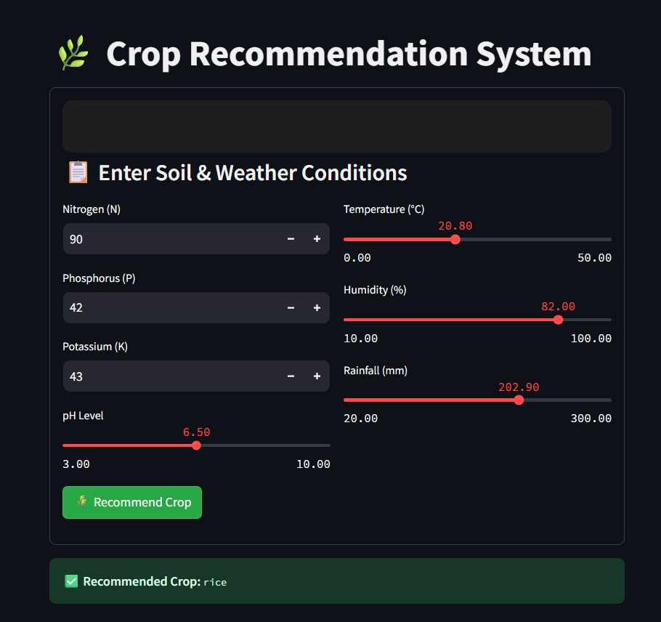

2. Crop recommended based on input: Coffee: Streamlit UI with input values recommending coffee.

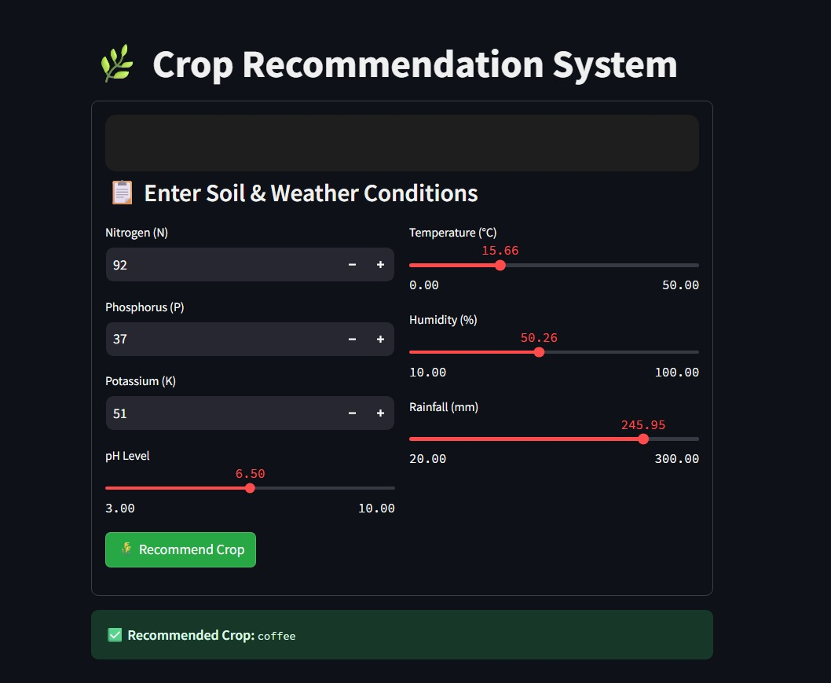

3. Model Accuracy - Terminal output showing model training results and command-line prediction of rice.

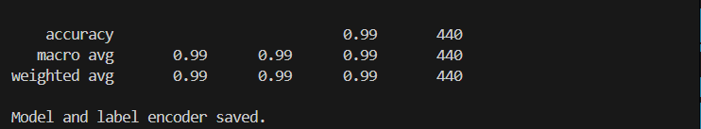

What you learned:
Through this project, I gained practical knowledge of:
- Machine learning model development using real-world agri-data
- Data preprocessing and label encoding
- UI creation using Streamlit
- Model evaluation and deployment using joblib
- Practical application of classification algorithms in precision agriculture

What the Skills you gained:

- Data preprocessing and cleaning
- Classification using RandomForest
- Model serialization and loading
- Building responsive ML web apps
- Agricultural domain problem-solving using ML

Real Time Applications:

- Crop recommendation for farmers based on soil test reports
- Agri-tech platforms or Kisan apps for smart farming decisions
- Government or NGO tools for guiding sustainable agriculture

Further Enhancement Suggestions :

- Add real-time weather API to auto-fetch live data for accurate predictions.
- Include fertilizer recommendations based on soil nutrients and crop.
- Deploy as a mobile app for better accessibility to farmers.
- Support multiple languages to make it user-friendly across regions.

